For Official Release
PR 003-04062023
Office of the Governor
Utulei, American Samoa
April 06, 2023
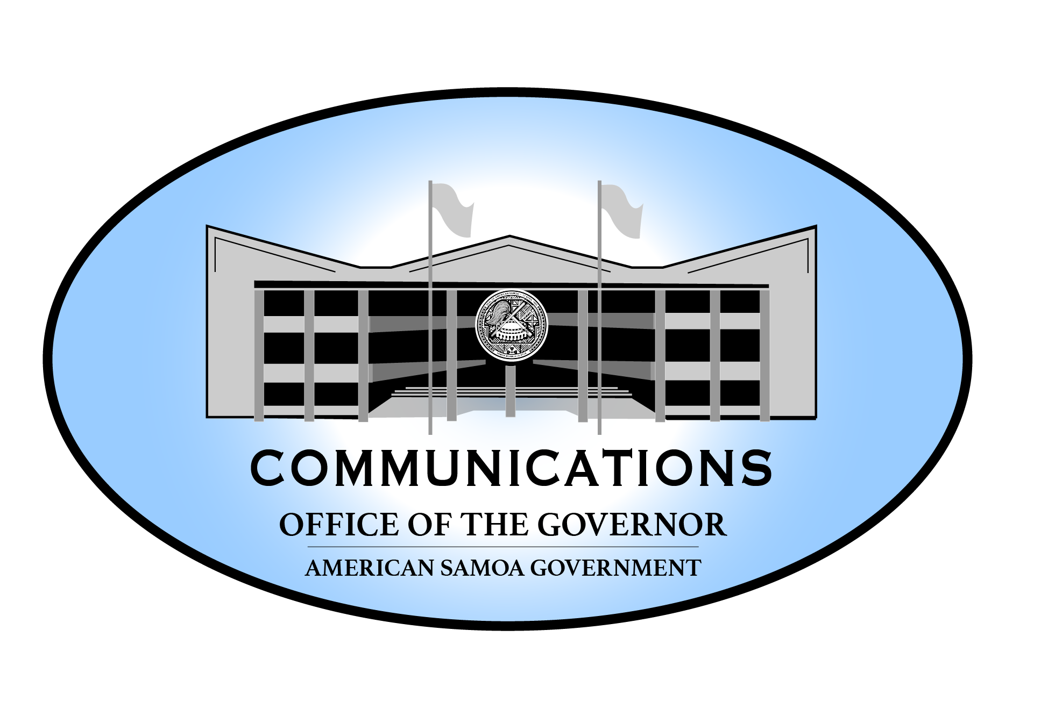
First Lady Ella and Good Lady Marian Hosts Dinner in Honor of
Women’s History Month
“Many women who constructed our way of life are no longer present, but their dedication reverberates in our communities today. American Samoa was built on their wisdom and their whispers of encouragement.”
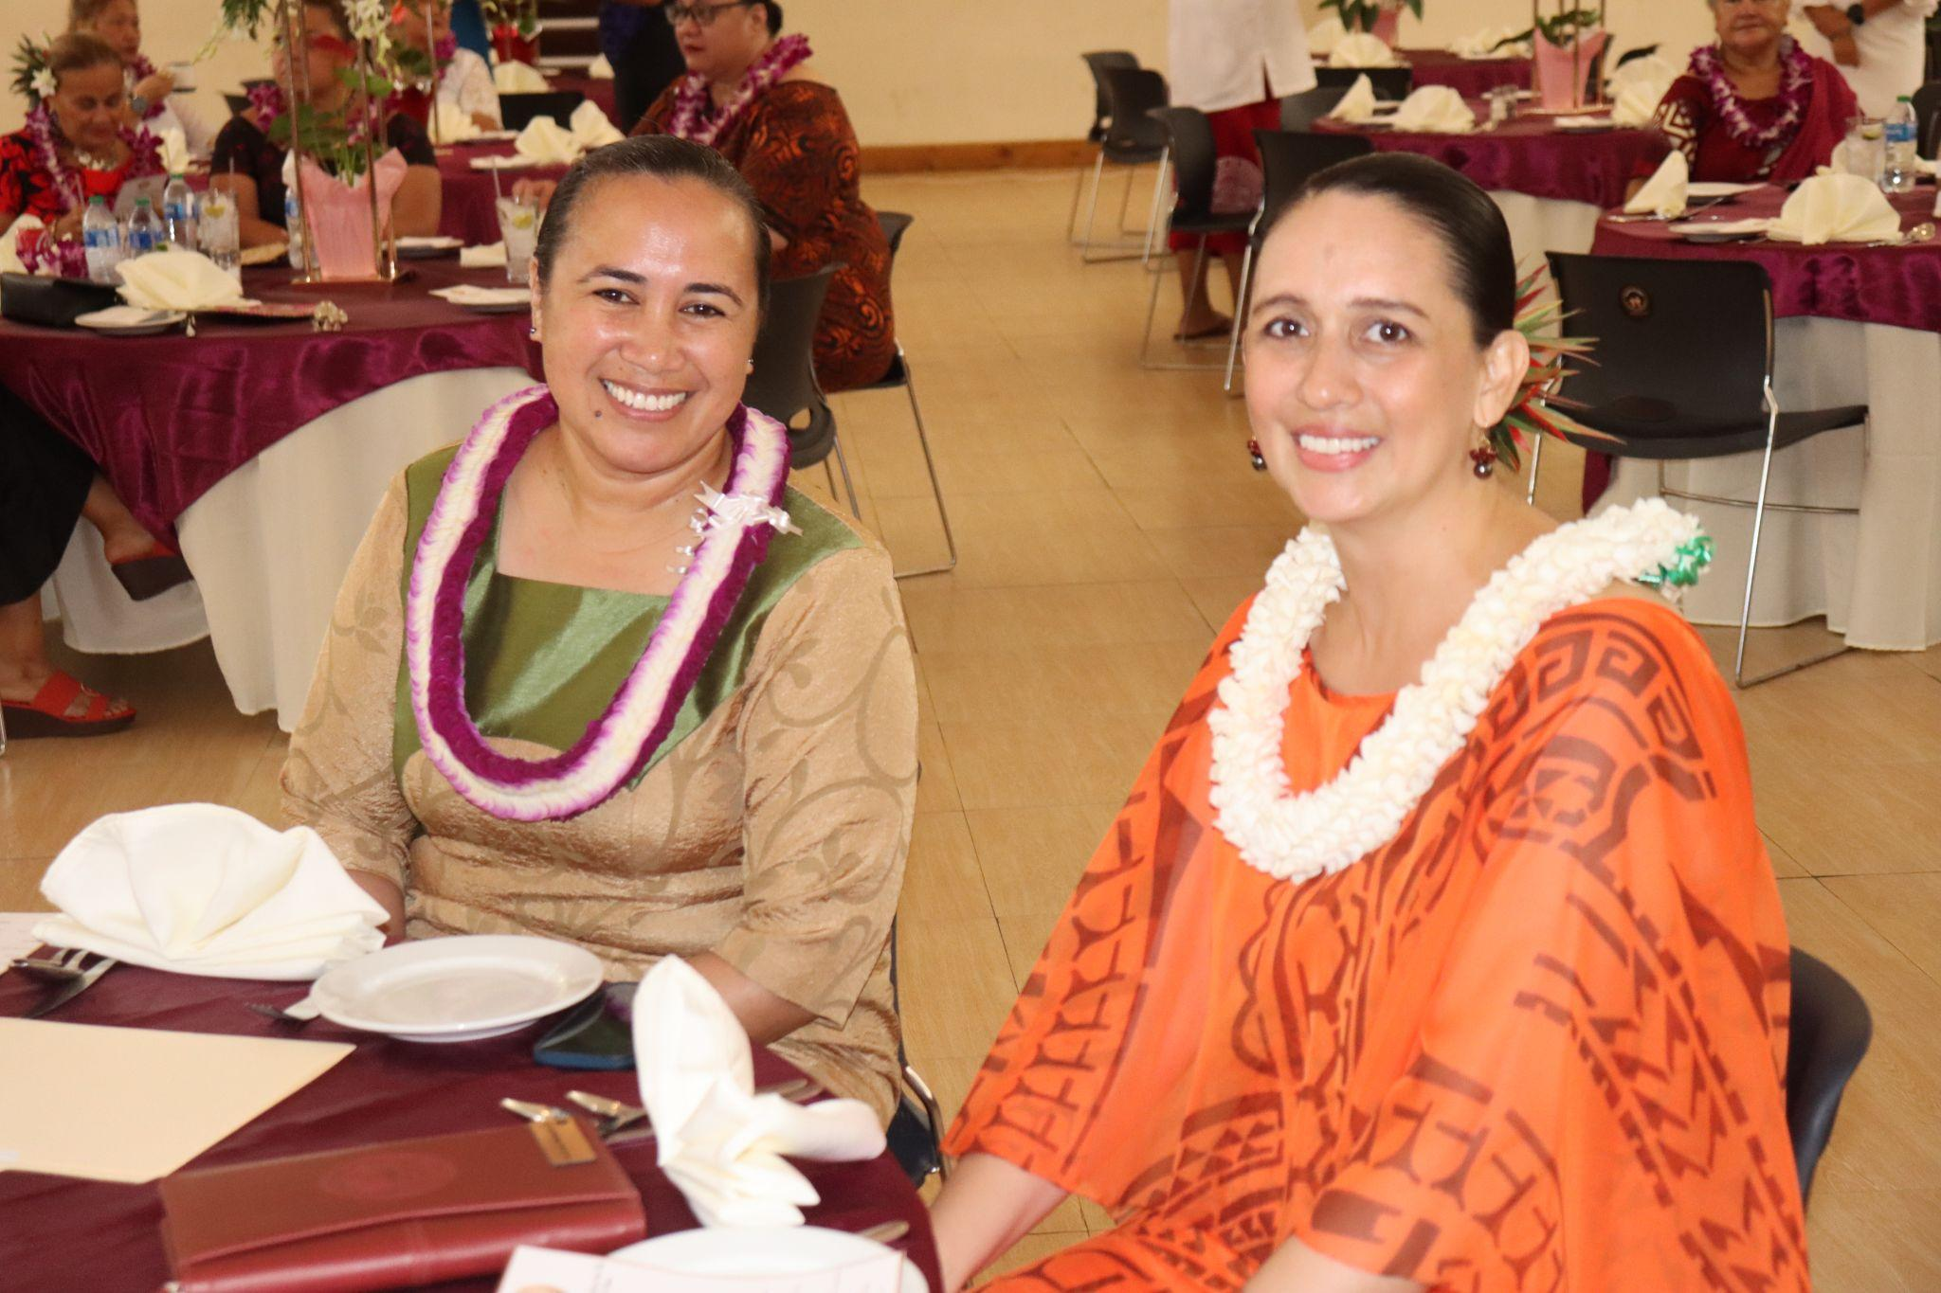

On March 30th, 2023, First Lady Ella Mauga and Good Lady Marian Ale hosted the culmination event in honor of Women's History Month at the Rex H. Lee Auditorium in Utulei. The theme of the evening was “Celebrating Women Who Tell Stories,” or “Fa’atauaina o Tina ma Tama’ita’i ma o latou sao.” Women of various communities of American Samoa were in attendance, and the guest of honor from the Independent State of Samoa, Afioga Filifilia Tamasese, Masiofo Tama Aiga Tui Atua Tupua Tamasese Efi. The Master of Ceremonies Peseta Tia Seloti anchored the ceremony for the evening. The Invocation and Benediction was conducted by Faletua Patricia Fuiava.

A special tribute presentation and musical selection was performed by First Lady Ella to celebrate the women pioneers of the past. She remarked,“Women are the epitome of strength and courage, and are the true architects of our society. The bravery and sacrifice the Samoan women make is reflected in the biblical story of Queen Esther to Mordecai when she quoted ‘And if I perish, I perish.’ ” First Lady Ella continued, “Many women who constructed our way of life are no longer present, but their dedication reverberates in our communities today. American Samoa was built on their wisdom and their whispers of encouragement.”

The guests enjoyed an extravagant evening commemorating the stories of iconic women, singing and dancing, musical performances, and encouraging conversations of the significance of Samoan women.

In her special remarks, Masiofo Filifilia described her life growing up and the women she was impacted by. She commended the First Lady and Good Lady for their efforts in paying tribute to Samoan women who have built our governments, and shaped our way of life.

Good Lady Marian delivered her final remarks commending all the guests for their accomplishments, camaraderie, and for their dedication to American Samoa.

###
